Hi, My name is Rajan & I’m starting this lecture series for Python. Please read and give me feedback.

Dividing Python into 4 parts

Module 1. Basics

Module 2. Functional Programming

Module 3. Data Analytics (NumPy and Pandas)

Module 4. ETL (Extract Transform Load)

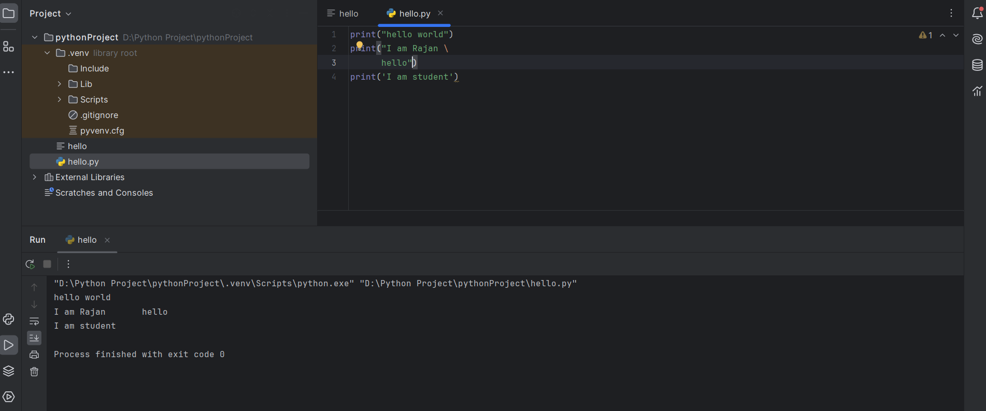

While writing print statement in Angular we cannot write it in new line, because Python treats every line as code line

Types of data type, no need to give any defined data type

1. String
2. Numbers
3. Floating Point number

#Checking data type   
print(type(a))

Python

1. Pip is external manager who import external data

2. Read evaluate learn

Strings are Immutable in Python

Print(a[0,4])

Print(len(a))

Print(a.upper())

a="!!!!!!Harry!!!"

print(len(a)) -> 14

print(a.upper()) ->!!!!!!HARRY!!!

print(a.upper()) ->!!!!!!harry!!!

print(a.rstrip()) ->!!!!!!HARRY

print(a.replace("Harry" "John")) -> !!!!!!John!!!

a.capitalized

a.count("harry")

a.endswith("!!!") ->TRUE/FALSE

a.find("is")

a.isalnum()

a.index("is")

If

elIf

else

import time

timestamp= time.strftime('%H:%M:%S')

print(timestamp)

match case statement

no break statement

code

x = int(input("Enter the value of x:"))

match x:

case 0:

print("x is zero")

while and else can be used

example of do while in Python

do while

i=0

while True:

print(i)

i= i+1

if i%100 == 0 :

break

Print(f “{name} {lastname} lives in Pune”)

for i in range(12):

if i == 10:

continue/break

print("5 X", i+1, "=", 5 \* (i+1))

age = int(input())

Python is not compiled it is interpreted(Line by line code execution in Python)